# IOT Enabled Smart Farming Applications

|  |  |
| --- | --- |
| YANNAM LOKESH REDDY | (410719104121) |
| PEMMASNI ABHINAYA CHOWDARY | (410719104002) |
| DESIREDDY NANDIVARDHAN REDDY | (410719104021) |

SIRIGIREDDY SWETHA (410719104099)

# SOLUTION FIT

**Project Title: Project Design Phase-I Team id: PNT2022TMID28746**



E



x



p



l



o



r



e



A



D



e



**fi**



n



e



C



S

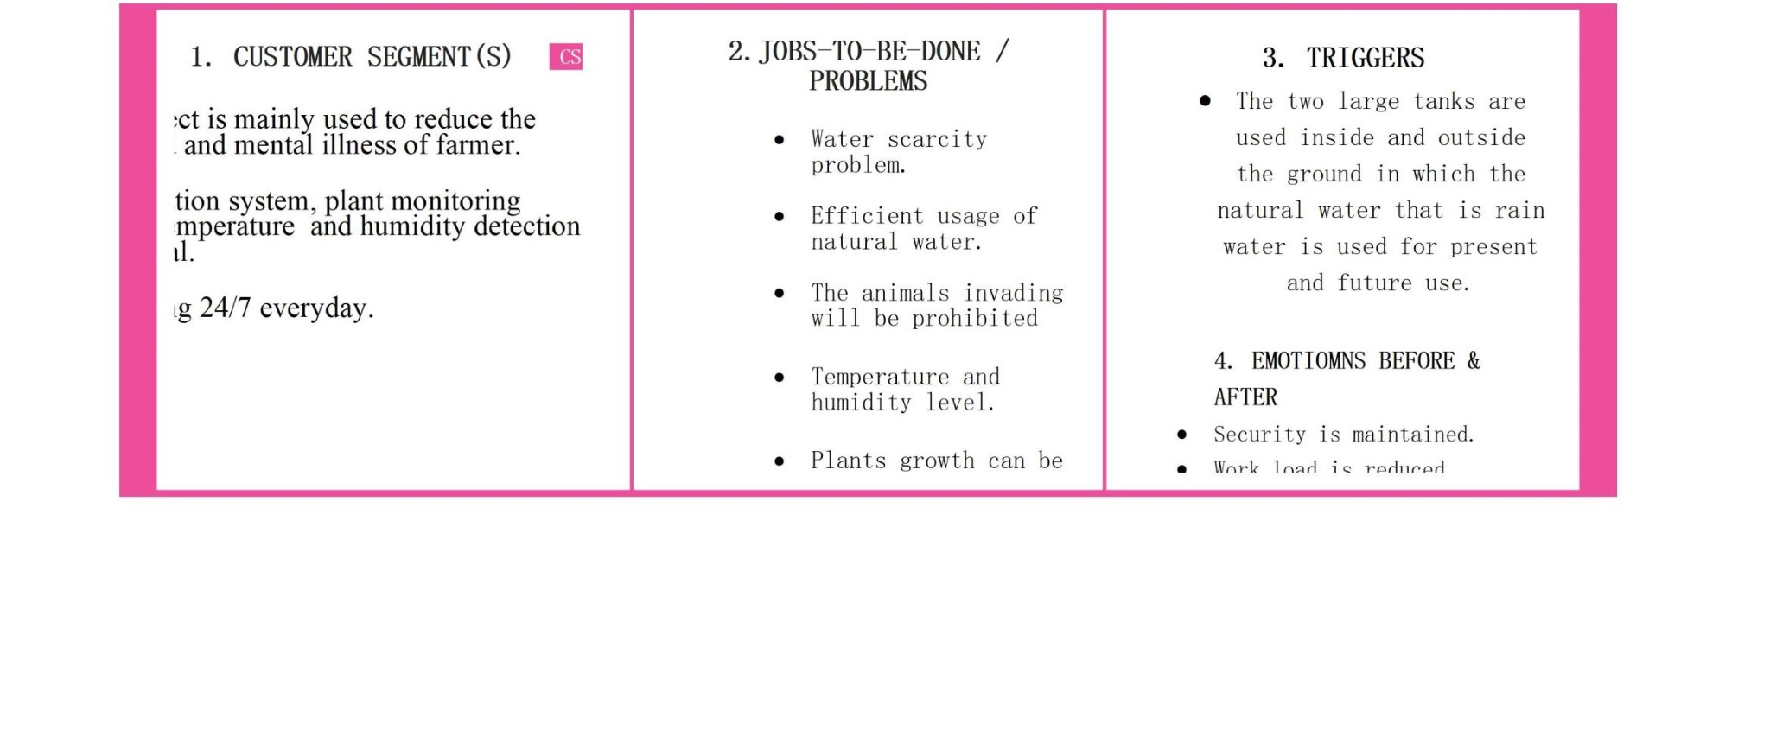

F



o



c



u



s



o



n



J



&



P



,



t

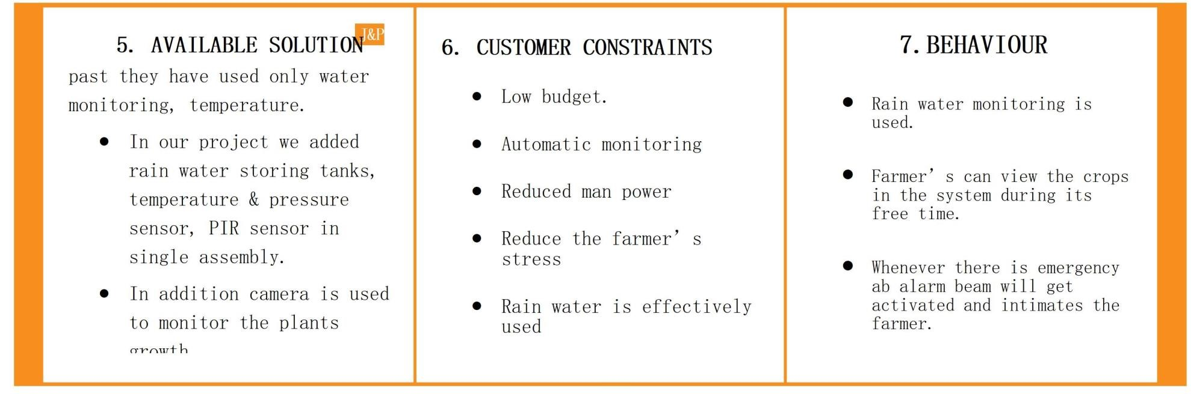

IOT ENABLED SMART FARMING APPLICATION **Solution Fit Template**

|  |  |  |  |  |
| --- | --- | --- | --- | --- |
|  | 8.CHANNELS OF BEHAVIOUR   * ONLINE : Nutrients of the plants, humidity, temperature, motion of animals through app. * OFFLINE : The equipments and components should be checked. | 9. PROBLEM OF ROOT CAUSE   * Ground water scarcity problem is solved by using rain water. * Animal invading is prohibited. * Temperature & humidity is maintained. | 10. YOUR SOLUTION  The plant is monitoring with less power. The  implementation cost    24/7  The rare crops can also grown.  Automatic monitoring wit is low. using man power. be  hout |  |
|  |  |
|  |  |